**KARANAM YESWANTH TEJA(289224)**

**Windows Subsystem for Linux 2 (WSL2): A Complete Guide for Windows 10 & 11**

**Step 1:** Create a wsl.bat file in your Startup folder (C:\Users\User\AppData\Roaming\Microsoft\Windows\Start Menu\Programs\Startup) with the content: wsl --shutdown

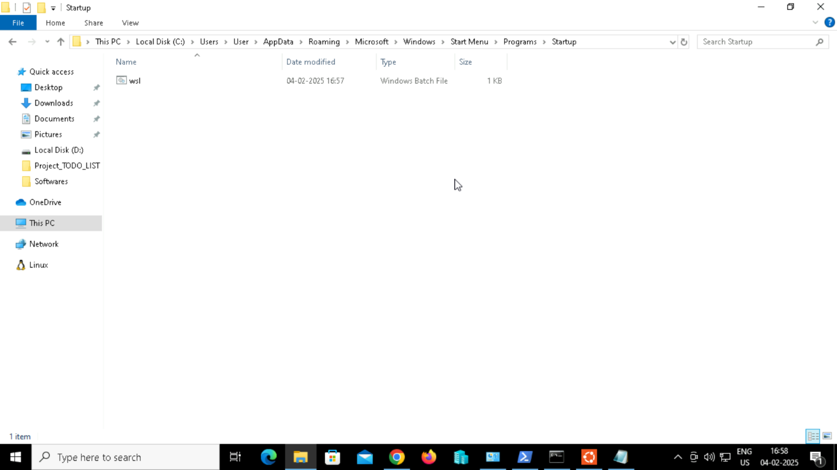

**Step 2:** Configuration is available from the Settings menu item (Ctrl + ,), the Command Palette (Ctrl + Shift + P), or the settings.json accessed at the bottom of the Settings panel.

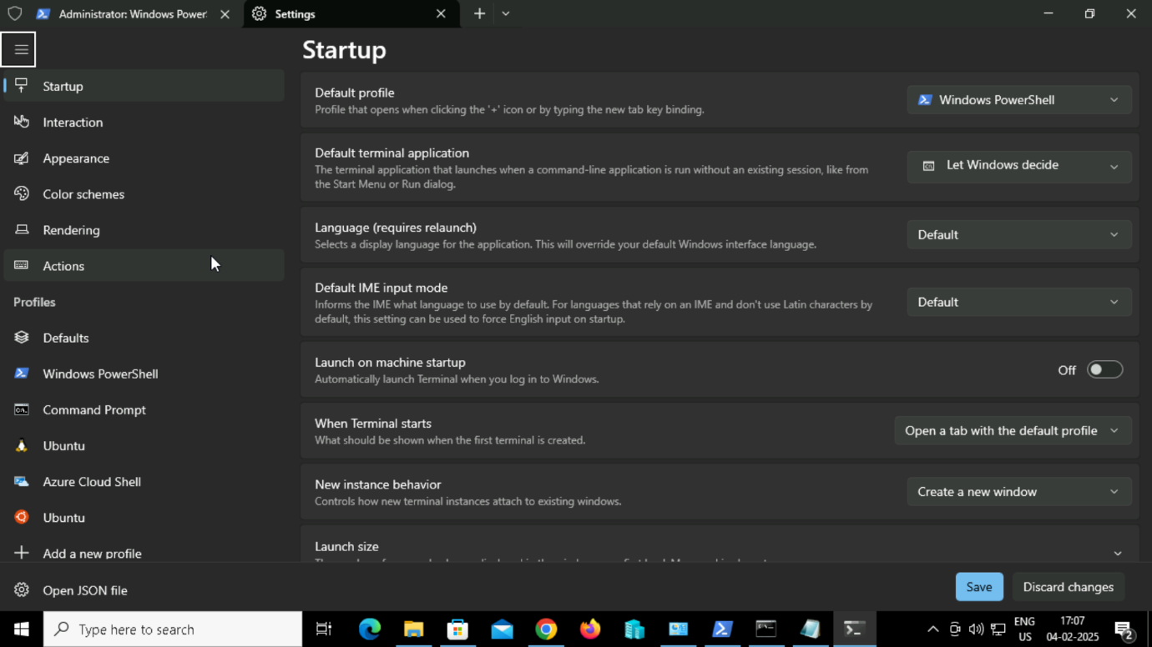

**Step 3:** The Virtual Machine Platform and Windows Subsystem for Linux features must be enabled in Turn Windows features on or off option. The panel is accessed by hitting Start and typing “features” or from the Programs and Features icon in the classic Control Panel.

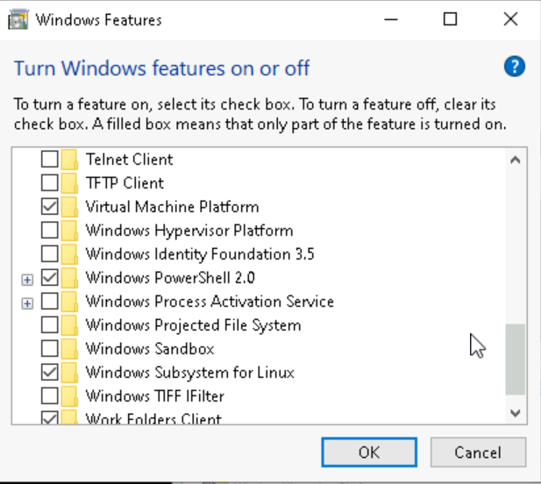

**Step 4:** Open Windows Powershell as Open as Administrator.

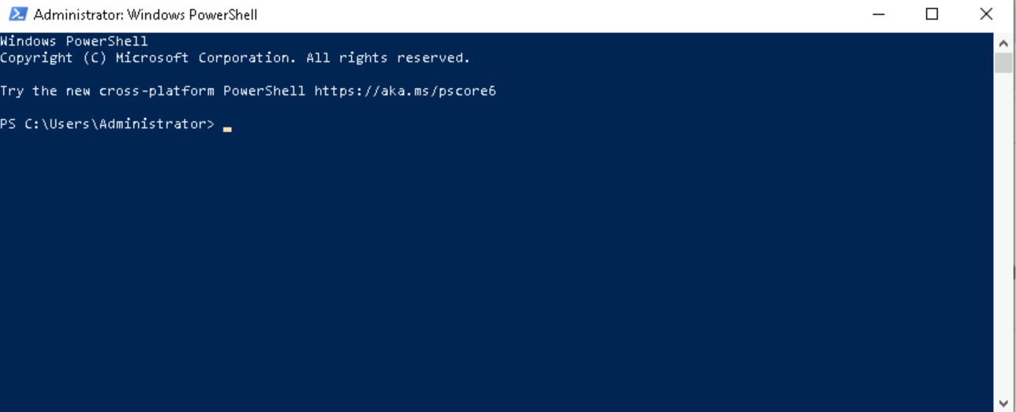

**Step 5:** Updating the windows subsystem using the below command.

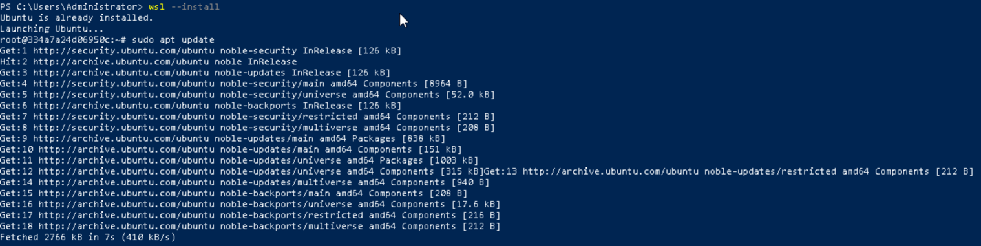

**Step 6:** Switch Between WSL1 and WSL2 - Existing WSL1 distros can be converted to WSL2. For that, enter the following command in a Windows Powershell terminal to display the installed Linux distros and their WSL version:

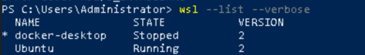

**Step 7:** Try switching between wsl1 and wsl2.

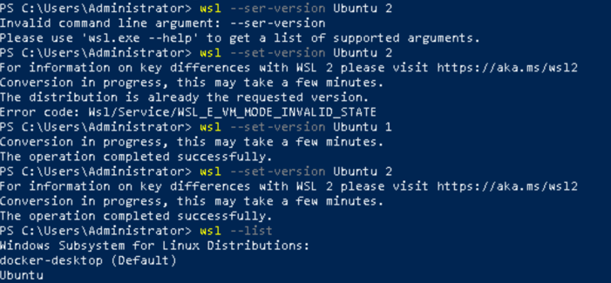

**Step 8:** Clone Linux Disk Image.

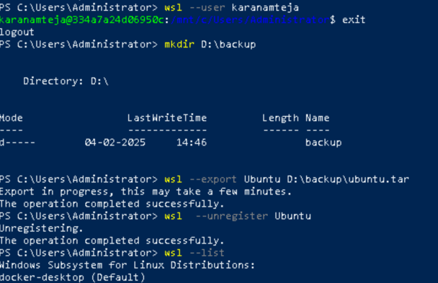

**Step 9:** Import the backup into a new WSL2 distro at another location, such as D:\wsl

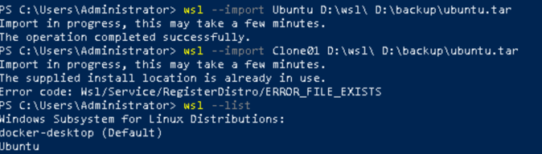

**Step 10:** Accessing Linux Files from windows and mapping a network drive.



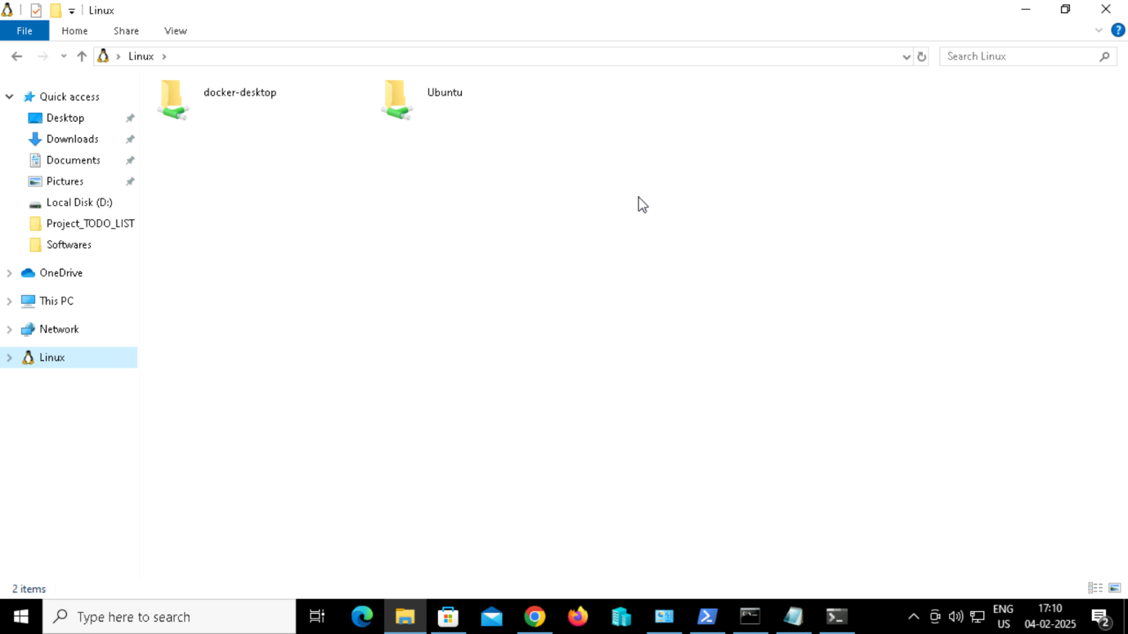

**Step 11:** Accessing the windows files from Linux.

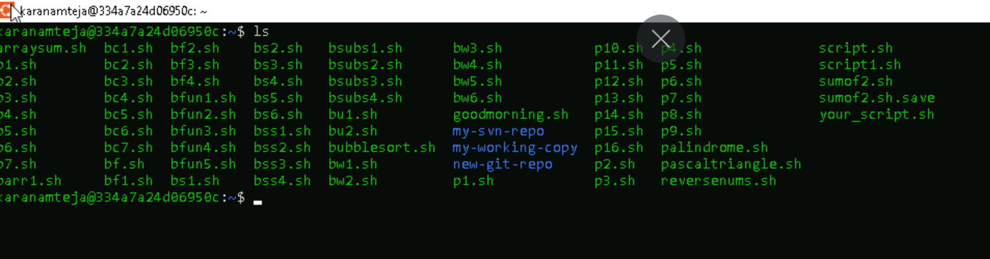

Step 12: Executing the linux commands from windows.

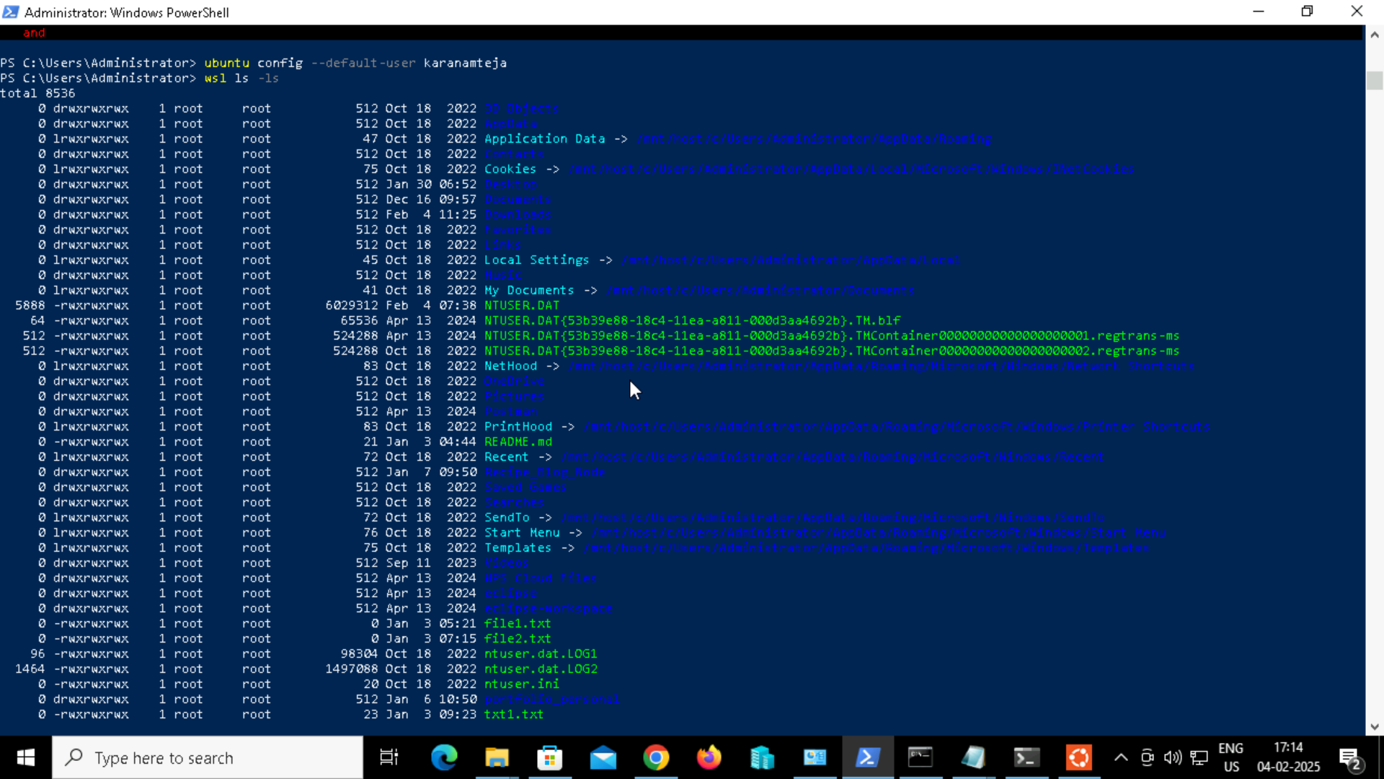

**Step 13:** Run Windows commands from Linux.



